MODULE III
- COMMERCE ARCHITECTURE AND SYSTEM DESIGN
- E-COMMERCE ARCHITECTURE
It comprises of,
- Infrastructure
- Data Flow of Infrastructure
- Process Control of Infrastructure
- Optimizing Method of Infrastructure
- Event Process Control of Infrastructure
i.Infrastructure
The infrastructure of e-commerce is:

.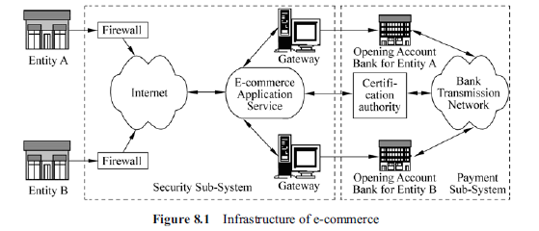
- E commerce entity A submits a business request, and sends request information and bank account information to the e-commerce application service center provided by the e-commerce ASP through the Internet.
- The intelligent search engine searches the appropriate trade entity B on the Internet, and sends the request information to entity B through the Internet.
- After entity B receives the request from entity A,
-entity B responds to the trading request after analyzing and handling
-then sends the response information and its bank account information to the
e-commerce application service center after analyzing and handling with the request.

- E-commerce application service center authenticates identities of both sides,and sends the authenticated bank account information to the banks, which they open their accounts through payment gateway, and then completes bank account transformation through bank private network
- The transferred information is sent to the trading entities through the e-commerce application service center.
- The delivery is completed with the help of some cooperated organizations, such as industry and commerce, revenue, law and transportation.
The e-commerce infrastructure can be divided into two relatively independent sub-systems.
- E-commerce security sub-system
- E-commerce payment sub-system.
The e-commerce security sub-system is in charge of handling security issues of information interaction in the e-commerce trade process.
The e-commerce payment sub-system is in charge of handling the electronic payment issues in the e-commerce trade process.

ii.Data Flow of Infrastructure

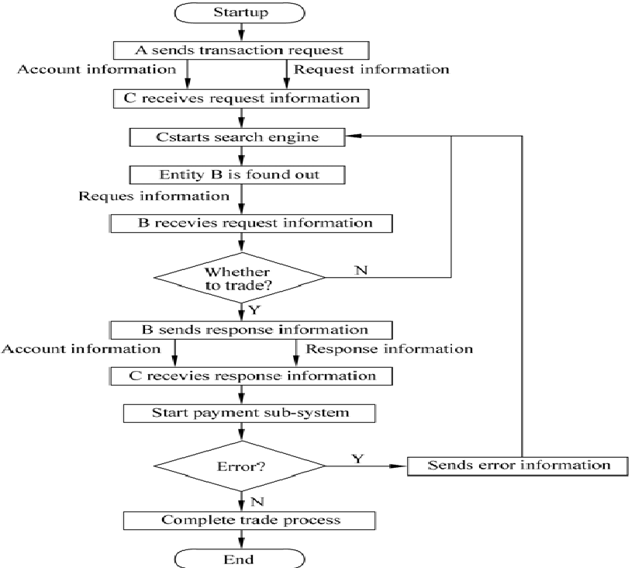

iii.Process Control of Infrastructure
The process control of e-commerce infrastructure can be divided into the following parts:
- A sends a business request to C
- 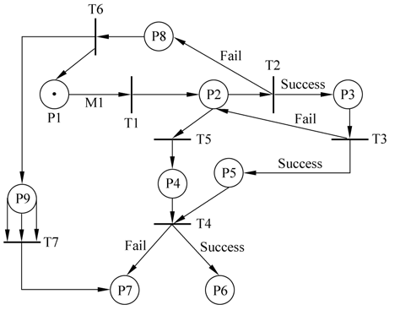
- A has an e-commerce request, making transition T1 in the enabled state; there is no token at other positions..
- Information M1 whose format could be represented as (A, C, T1, Request) is an encapsulated information Package.
- T1 represents that the e-commerce entity A sends business request to the e-commerce entity C.
- The transition t1 meets the triggering condition, and could be triggered at any time and can cause the change of the system state of the Petri net.
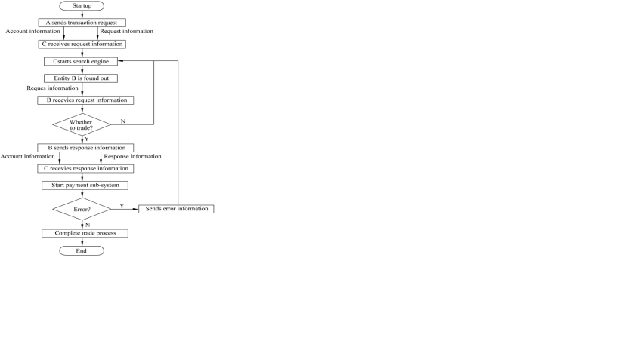

2. C accepts A’s Request, and prepares to start agent to search the appropriate
entity B
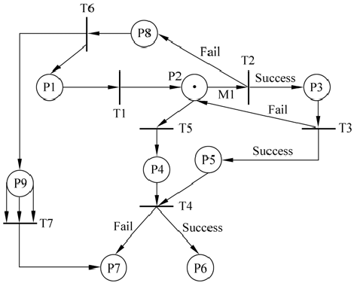

- The result of the triggering of T1 is that A sends information package M1 to C
- C accepts M1, sends response information to A and at the same time prepares to start several intelligent agents to search the e-commerce entity B that meets the request, that is position P2.
- Position P2 owns one token, P1 loses the token, and T1 completes the triggering.
- The token of P2 means that transitions T2 and T5 could be triggered,that is C sends the response signal to A, and prepares to start intelligent agent to search the appropriate entity B at the same time.
- When the only forward element of transitions T2 and T5 owns a token, the triggers of these two transitions could complete in parallel, without the conflict problem.

3. C sends a response to A, and starts an agent to search the appropriate entity
B at the same time
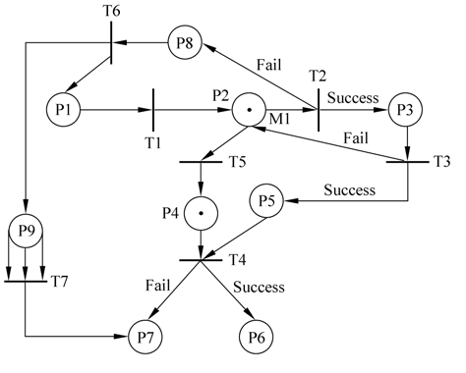
The trigger of transition T2 is little complicated, because transition T2 is a condition judgment transition, which may lead to two different possible results.
- Find an appropriate entity B
- Not find an appropriate entity B

Entity B will decide whether to trade with A based on the Request sent by A.
(1) E-commerce trading process
If B accept A’s Request, T3 will obtain a positive trigger (that is success), and sends a response information package M2 to A. The format of M2 is: (A, C, T1, Response). The Petri net model of the infrastructure is shown as Figure.
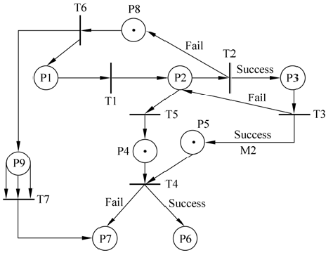
(2) Do not make e-commerce trade
If B cannot meet the business Request of A, T3 gets negative trigger (that is fail). Position P3 loses the token, and P2 gets the token and the whole Petri net model returns to the similar situation of step 2 (omitted).

- Start payment process
Both P4 and P5 own tokens, that means e-commerce entity A has a business request and entity B can meet A’s business request, transition T4 is triggered, and then the e-commerce payment process starts. However, because of the complexity of the payment protocol, the payment process is actually possible to fail, so it’s necessary to consider the following two points:
(1) The payment process succeeds, and the e-commerce interaction completes If the payment subsystem runs well, the Petri net model of the infrastructure evolves to Figure:

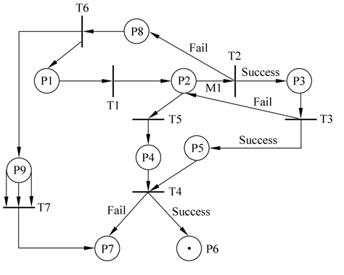
The transition T4 is positively triggered, and P6 obtains a token, which indicated the e-commerce interaction completes normally.
(2) The payment process fails, and the e-commerce interaction could not be completed
If errors appear in the running process of the payment subsystem, the evolvement of the Petri net model could also be presented with the corresponding Petri net (omitted). Then the transition T4 is negatively triggered (namely fail), and P7 obtains a token, indicating the e-commerce interaction is abnormally stopped.

iv.Optimizing Method of Infrastructure
The optimizing process of e-commerce infrastructure needs to be constructed in terms of the following optimizing rules:
1. Reachability
- To prove that whether a model system could reach the specified state through a certain functional behavior, designers need to find a chain generated by transition trigger.
- The system can reach the specified state mi along the transitional activating chain from the initial state m0 , and the chain represents a series of functional behavior.

- Boundedness

- The concept of bounded is introduced into the system model based on Petri net to handle the overflow problem of information storage unit.
- A k-bounded position p means the total of tokens must be less or equal to k in the changing process of the system states (m₀₋mi ). If all of the positions in a Petri net model are k-bounded, the Petri net model is called k-bounded.

3. Conservativeness
If a token is used to represent resource,the quantity of tokens in a system is usually conservative, that is however the state of the system changes, the quantity of the tokens in the Petri net model of the system is always unchangeable.
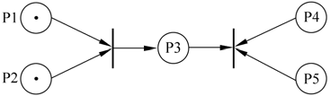
4. Activity
The concept of activity is tightly connected with deadlock.To avoid deadlock, a Petrinet model must exclude the following four cases:
-Resource monopolized
-Keep waiting
-Non- deprivation
-Form waiting circle
5. Resumption
An important problem in the model analysis based on Petri net is whether a system has error-resuming function; that is to say the system can self-resume from an error state to a correct state.
6. Common optimizing models
We can use the following common optimizing models in the optimizing process of e-commerce infrastructure.

v.Event Process Control of Infrastructure
Several forms mainly for the process control of e-commerce system events are as follows:
1. Sequential relation
If the occurrence of E1 is the condition of E2’s occurrence, E1 has sequential
relation with E2.

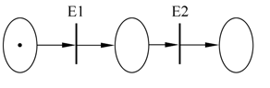
2. Conflict relation
If E1 and E2 cannot occur concurrently, E1 and E2 are conflict mutually

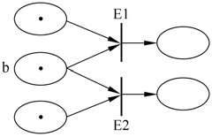

- Collision relation

If occurrence of E1 or E2 can result in the change of certain position state, we define that the position has collision with E1 and E2.

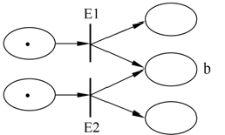
4. Concurrent relation
If E1 occurs before E2, the system could reach a certain state. If E1 and E2 occur concurrently, it also could reach the same state, and there is no conflict, which means E1 and E2 have concurrent relation.
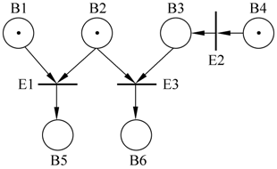

2. E-COMMERCE SECURITY SYSTEM
1. OSI security architecture
The e-commerce system built on the basis of Internet not only needs to handle various security issues, but also must meet some specific security control requirements in e-commerce interaction.
OSI security architecture defines functions of security services, security mechanism and security management, and presents the logical relations among OSI network layers, security service and security mechanism. OSI prescribes five standard security services:
- Object authentication security service: both sides of communication authenticate the validity and authenticity of each other, to prevent cheat.
- Access control service: used to prevent unauthorized users to use the system resources illegally.
- Data secrecy service: used to prevent information to be intercepted or betrayed by illegal entities.
- Data integrity service: used to prevent the change, insert, delete exchanged data form illegal entities and lost of data.
- Preventing denying security service: used to prove occurred operations, and prevent the denying of the happened behaviors.Security service is implemented by security mechanism. OSI defines eight types of security mechanisms: encryption mechanism, signature mechanism,access control mechanism, data integrality mechanism, authentication exchange mechanism, business flow filling mechanism, route control mechanism and notarization mechanism.
2. E-commerce security factor
(1) Validity: Controlling and preventing the hidden threat caused by network failure, operation error, application error, hardware failure, system software error and computer virus, to guarantee trade data valid at certain time and in certain place.
(2) Confidentiality: E-commerce is built on the open Internet environment, and maintaining business confidentiality is an important safeguard for widely spreading e-commerce application. Therefore, it’s necessary to prevent illegal access of information and to prevent information from to be wiretaped in the transmission.
(3) Integrality: E-commerce system should prevent to generate, update and delete information arbitrarily, avoid losing and repetition of information and guarantee the order of information transmission.
(4) Reliability: It’s impossible to distinguish handwriting signature and seal in the non-paper e-commerce mode, so reliable identifiers are needed for individuals,enterprises or countries involved in information transmission in an e-commerce transaction.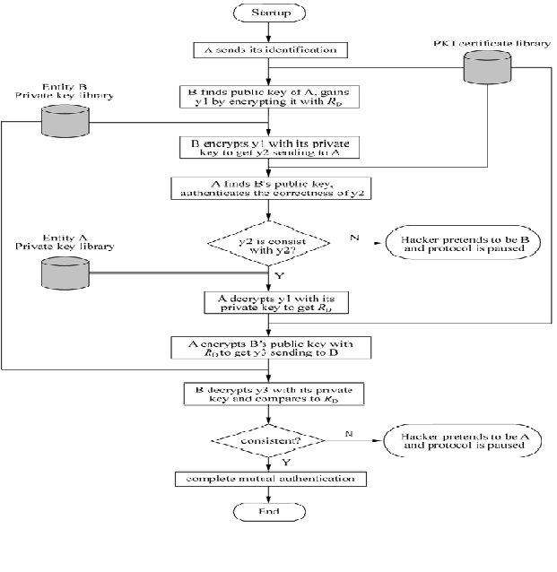
3. E-COMMERCE PAYMENT SYSTEM
1. E-commerce and Online Payment
Electronic payment is an important component of e-commerce, and a complete e-commerce operation process typically includes three links that are market information communication, fund payment and goods distribution.Online capital payment plays connecting part in the whole process.
Example:
Civil aviation and railway also expect to sell tickets on the Internet. Government also expects to take various revenue on the Internet.

2. Data Flow and Process Control of Payment System

- Cardholder register and apply
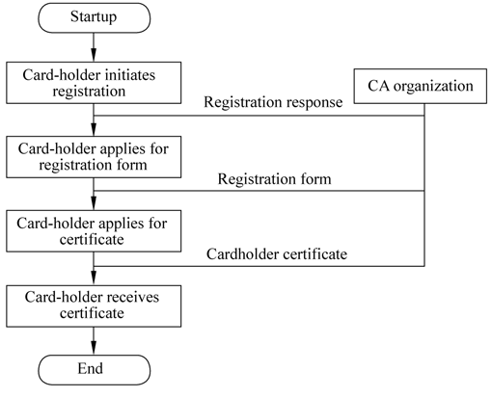
The process in the flow chart is described as follows:
- Starts payment system, and sends an initial request to CA.
- CA sends a response: when CA receives the request, it sends its certificate to the cardholder
- The payment system receives the response, and applies to register the registration form.
- CA deals with the request and sends the registration form.
- The cardholder receives the registration form and requests a certificate.
- CA deals with the request and issues a certificate.
- The cardholder receives the certificate.
- The seller registers and applies the certificate.

2. Purchase request
- The cardholder sends an initial request.
- The cardholder sends an initial purchase request to the seller after making choice of goods.
- The seller responds to the request and sends a certificate.
- The seller sends a response after receiving the request; the response message of the seller generates digital watermark by a hash function; then digital signature is formed by using the private key of the seller; at last, the response message, the seller’s certificate and gateway certificate together are sent to the cardholder.

